02/01/13
61 348 Service Operations Management
Final Exam Answer Sheet
- Sami is the general manager of El Mouradi Club Kantaoui. He recently observed a decline of occupancy rates as well as increase in the number of complaints placed by guests. He decided to investigate the matter. He called department managers and supervisors for an urgent meeting and requested that they thoroughly brainstorm reasons of the decline of occupancy rates and report them within 2 days. When reports came, Sami grouped possible problems, (along with frequencies) in the following table:
Problem Area | Frequency
Poor services rendered | 30
Misbehavior of employees | 4
Dirty rooms | 26
Sanitation problems | 16
Spoiled food | 10
Erroneous billing | 12
- Prepare a Pareto Chart for the above data. (2 Points)
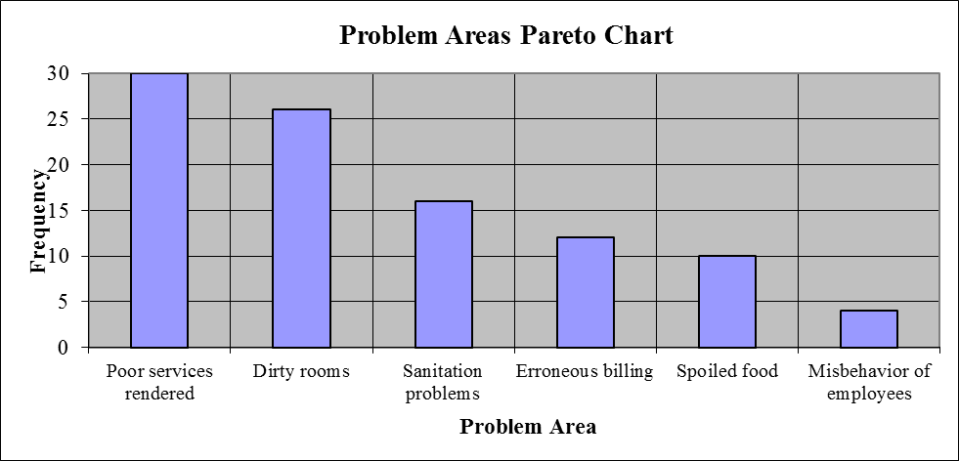
- As “Poor services rendered” problem had the highest frequency amongst the other problems, Sami decided to tackle this first. He contracted with an international training company to re-train hotel’s employees and approved a new remuneration system that links salary with excellence in services rendered. After 12 months, he wanted to see if there are any improvements in services rendered. To see this, he decided to use run chart. He prepared the following table depicting monthly guests’ complaints (before / after retraining employees and approval of new remuneration system. The following table reveals the results:
Month | Guest Complaints (Before) | Guest Complaints (After)
1 | 45 | 30
2 | 42 | 25
3 | 48 | 20
4 | 55 | 32
5 | 52 | 37
6 | 65 | 40
7 | 75 | 42
8 | 90 | 44
9 | 84 | 34
10 | 63 | 30
11 | 50 | 23
12 | 46 | 18
Prepare a run chart to compare guest complaints before and after retraining employees and approval of new remuneration system. (2 Points)
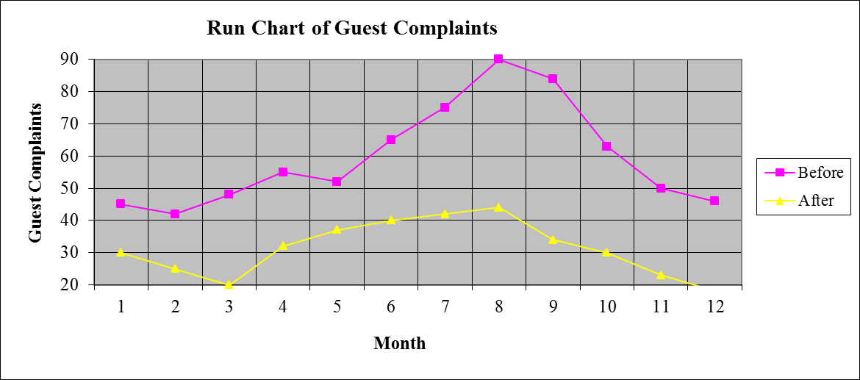
c) Analyze the finding in part b). Is there any improvement as far as guest complaints are concerned after retraining employees and approval of new remuneration system? If there is an improvement, what is the next problem that Sami shall try and solve? (1 Point)
As far as the run chart prepared in part b) is concerned, we can say that there is an improvement in guest complaints after retraining employees and approval of a new remuneration system. That’s why; Sami shall try and tackle the next highest frequency problem which is “Dirty rooms”.
- What is / are the advantage(s) and disadvantage(s) of a service encounter being dominated by the service organization? Provide 2 examples of worldwide companies dominating the service encounter. (4 Points)
Some of the advantages of a service encounter being dominated by the service encounter might be:
- Seek cost efficiency
- Follow cost leadership strategy
- Standardize service rendered
- Impose strict operating procedures → Limit the discretion of contact personnel
Some of the disadvantages of a service encounter being dominated by the service encounter might be:
- Customer is left with few standardized options from which to chose
- No customization of services
- Contact personnel has no autonomy to deal with different customer needs
- Job satisfaction of contact personnel will diminish
McDonald’s, Jiffy Lube and H & R Block can be good examples of worldwide companies dominating the service encounter.
- During the past season, Fatma Resort Hotel did not achieve very high occupancy rates despite a reservation system that was designed to keep the hotel fully booked. Apparently, prospective guests were making reservations that, for one reason or another, they failed to honor. A review of Front-desk records during the current peak period, when the Resort Hotel was fully booked, revealed the record of no-shows as shown in the below table:

No-shows | Probability | Reservations Overbooked | Cumulative Probability
0 | 0.10 | 0 | 0.00
1 | 0.15 | 1 | 0.10
2 | 0.17 | 2 | 0.25
3 | 0.09 | 3 | 0.42
4 | 0.08 | 4 | 0.51
5 | 0.16 | 5 | 0.59
6 | 0.10 | 6 | 0.75
7 | 0.04 | 7 | 0.85
8 | 0.05 | 8 | 0.89
9 | 0.04 | 9 | 0.94
10 | 0.02 | 10 | 0.98
Suppose that a vacant room (because of No Show) results in an opportunity loss of $ 80.
- Calculate the Expected Number of No Show Rooms. (2 Points)
- Expected Number of No Show Rooms = (0 * 0.10) + (1 * 0.15) + (2 * 0.17) + (3 * 0.09) + (4 * 0.08) + (5 * 0.16) + (6 * 0.10) + (7 * 0.04) + (8 * 0.05) + (9 * 0.04) + (10 * 0.02) = 0 + 0.15 + 0.34 + 0.27 + 0.32 + 0.80 + 0.60 + 0.28 + 0.40 + 0.36 + 0.20 = 3.72 Rooms.
- Calculate the Expected Opportunity Loss. (1 Point)
- Expected Opportunity Loss = 3.72 * 80 = $ 297.60.
In order to avoid some of this loss, Fatma Resort Hotel management is considering an overbooking policy. Yet, if a guest holding a reservation is turned away (due to overbooking), other costs would be incurred. Fatma Resort Hotel has made arrangements with a nearby Resort Hotel (Chafra Resort Hotel) to pay for the rooms of guests whom it cannot accommodate. Further, a penalty is associated with the loss of customer goodwill and the impact this has on future business. Management estimates this total loss to be approximately $ 140 per turned out guest.
- Fill the below Overbooking Loss Table (3 Points)
 |  | Reservations Overbooked
No-shows | Prob. | 0 | 1 | 2 | 3 | 4 | 5 | 6 | 7 | 8 | 9 | 10
0 | 0.10 | 0.00 | 140.00 | 280.00 | 420.00 | 560.00 | 700.00 | 840.00 | 980.00 | 1,120.00 | 1,260.00 | 1,400.00
1 | 0.15 | 80.00 | 0.00 | 140.00 | 280.00 | 420.00 | 560.00 | 700.00 | 840.00 | 980.00 | 1,120.00 | 1,260.00
2 | 0.17 | 160.00 | 80.00 | 0.00 | 140.00 | 280.00 | 420.00 | 560.00 | 700.00 | 840.00 | 980.00 | 1,120.00
3 | 0.09 | 240.00 | 160.00 | 80.00 | 0.00 | 140.00 | 280.00 | 420.00 | 560.00 | 700.00 | 840.00 | 980.00
4 | 0.08 | 320.00 | 240.00 | 160.00 | 80.00 | 0.00 | 140.00 | 280.00 | 420.00 | 560.00 | 700.00 | 840.00
5 | 0.16 | 400.00 | 320.00 | 240.00 | 160.00 | 80.00 | 0.00 | 140.00 | 280.00 | 420.00 | 560.00 | 700.00
6 | 0.10 | 480.00 | 400.00 | 320.00 | 240.00 | 160.00 | 80.00 | 0.00 | 140.00 | 280.00 | 420.00 | 560.00
7 | 0.04 | 560.00 | 480.00 | 400.00 | 320.00 | 240.00 | 160.00 | 80.00 | 0.00 | 140.00 | 280.00 | 420.00
8 | 0.05 | 640.00 | 560.00 | 480.00 | 400.00 | 320.00 | 240.00 | 160.00 | 80.00 | 0.00 | 140.00 | 280.00
9 | 0.04 | 720.00 | 640.00 | 560.00 | 480.00 | 400.00 | 320.00 | 240.00 | 160.00 | 80.00 | 0.00 | 140.00
10 | 0.02 | 800.00 | 720.00 | 640.00 | 560.00 | 480.00 | 400.00 | 320.00 | 240.00 | 160.00 | 80.00 | 0.00
Expected | ------- | $297.60 | $239.60 | $214.60 | $227.00 | $259.20 | $309.00 | $394.00 | $501.00 | $616.80 | $743.60 | $879.20
Loss ($)
- How many rooms shall be overbooked? Why? (2 Points)
According to the above overbooking loss table, 2 rooms shall be overbooked, since, this very scenario yields the least expected loss.

- What is “Cross-Training”? List any 2 advantages of cross-training? (3 Points)
Cross-Training refers to training employees for more than one work position / responsibility area. Some of the advantages of cross-training are:
- Creates flexible capacity to meet localized peaks in demand
- Help to build an esprit de corps (Group / body spirit)
- Give employees relief from monotony
- Increase employees’ involvements in operations, and hence, make employees feel they are important for the company. This, in return, can boost morale, motivation, and productivity.
5. In the below figure, 4 quadrants of “Multisite and Multiservice Expansion Strategies” are found. Could you place the following 4 different services in their respective quadrant? (2 Points)
- American Express
- McDonald’s
- Stanford University
- Family restaurant
 |  | Single Service | Multiservice
Single Location
 |  | Family Restaurant | Stanford University
Multisite
 |  | McDonald’s | American Express
  - What is “Service Offshoring”? What are some of the management issues that need to be considered while using this very global service strategy? (3 Points)
“Service Offshoring” refers to sending back-office activities overseas to gain labor cost savings. Some of the management issues that need to be considered while using this very global service strategy are:
- Master of the language needed
- Extent and quality of training
- Control over operations
- Cultural differences

Good Luck

