FORECASTING

I- What is Forecasting?
Forecasting is a technique to estimate, based on historical figures, expectations, trends, and/or experience, a certain value of an uncontrollable variable for a certain future period of time.
Moreover, forecasting cannot be as simple as coming up with a figure, solely by considering only historical data, without adjusting to other variables like competition, image and risk of the country, interest rates, inflation, exchange rates, and other economical factors! Therefore, a person who forecasts shall adjust the forecasted figure to the realities and expectations for the upcoming period in question!

Forecasting

Judgmental

Statistical
(Time Series Models)

Trend Projection
Trend &
Seasonal

Smoothing
Expert
Opinion
Market
Surveys
Delphi
Technique

In the scope of this very course, Rooms Division Managers forecast mainly Room Demand for a future period of time measured either in:

- Number of Rooms
- Number of Room Nights
- Number of Guest Nights

• Room Nights = Occupancy Rate * Hotel Rooms * Average Length of Stay
• Guest Nights = Occupancy Rate * Hotel Rooms * Average Guest per Room

Forecasting demand in room nights and/or guest nights is a better measurement compared to number of rooms. For, room nights and /or guest nights underlies more than one demand dimension at the same time and hence is more meaningful!

II- Forecasting Methods:

Jamel Hotel’s Historical Room Nights for the past 20 years are depicted below:

Year: | Demand (Room Nights):
2005 | 6,520
2006 | 6,719
2007 | 7,060
2008 | 7,148
2009 | 7,612
2010 | 8,915
2011 | 5,430
2012 | 4,519
2013 | 5,029
2014 | 5,478
2015 | 6,769
2016 | 7,005
2017 | 7,345
2018 | 8,325
2019 | 8,975
2020 | 7,023
2021 | 7,453
2022 | 8,783
2023 | 9,324
2024 | 10,968

Could you forecast 2025 room demand in room nights only bearing in mind the above-mentioned historical data?

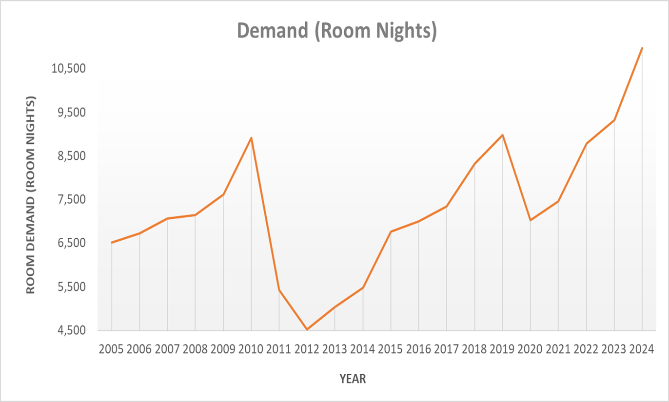

- Percentage Growth Method:
• The assumption underlying this method is that data in hand follow either an increasing or decreasing trend! That’s why; this very method shall be used, while forecasting, only when data matches the assumption!
During the last 20 years of operation of Jamel Hotel:
- The Total Percentage Change in Room Nights is (10,968 – 6,520) / 6,520 * 100 = 68.22 %
- The Yearly Percentage Change = 68.22 % / 20 = 3.41 %
- The Forecasted Room Nights for year 2025 is 10,968 * (1 + 0.03411) ≅ 11,342 Room Nights

- Moving Average Method:
• Similar to the “Percentage Growth Method”, the Moving Average Method assumes an increasing or decreasing trend!
• This very forecasting technique aims at smoothing data and adjusts it as to minimize volatility reflected in a high standard deviation between different records in the same data range!
• The most common used moving average is the Double moving average, which calculates a third column by taking averages of couples of any two successive years. Later, the percentage growth method would be applied to the smoothed data. Lastly, come up with the forecasted value.

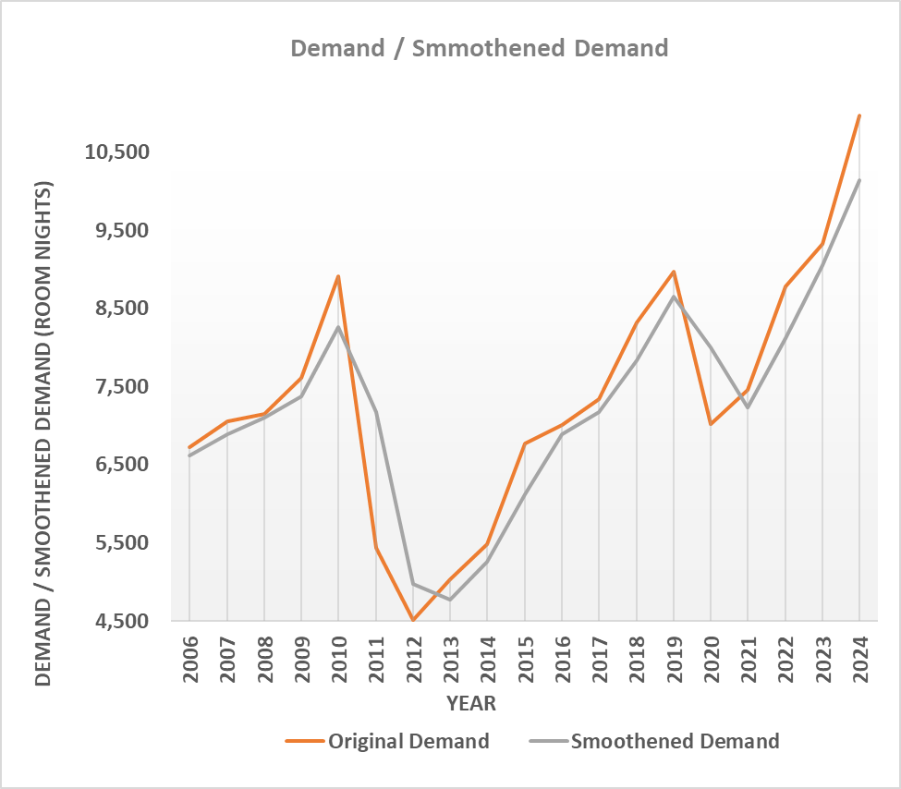
- The Total Moving Average Percentage Change = (10,146 - 6,619.50) / 6,619.50 * 100 = 53.27 %
- The Period Moving Average Percentage Change = 53.27 % / 19 = 2.80 %.
- The Forecasted 2024 - 2025 Moving Average = 10,011 * (1.028039) = 10,430.485.
- The Forecasted 2025 Room Nights = (10,430.485 * 2) – (10,968) ≅ 9,893 Room Nights.

- Weighed Average Method:
- The Weighed Average Method assigns Certain Importance Factor or Coefficient to each historical Value. Later, the forecasted value shall be computed by dividing the weighted data to its coefficients by the sum of coefficients.
- Assigning weights or coefficients is an art that depends on experience, thorough analysis of past figures, and performances… Yet, whatsoever coefficients chosen, there is always a certain subjectivity factor that might affect eventually the forecasted figure!
- One of the most common types of the weighted average method is the simplest method, which assigns the lowest weight to the oldest data in a sequential order.
- Though the simplest weighted average method is straight foreword, assigning least weight to oldest data assumes that:
- The factors affecting the oldest demand diminishes through time and hence are not important as far as the future period to be forecasted is concerned
- The factors affecting the last period’s demand are assumed to continue heavily playing an important role in the next period to be forecasted!
- If such assumptions are not valid for the data in hand, in most of the cases, hotels shall adjust the coefficients attributed in the simplest weighted average method in a way that mostly puts more weight on factors thought to affect next period’s demand and less weight to those which would be considered relatively unimportant!!
- Another possibility is that hotels shall, after finding a forecast from the simple weighted average method, adjust to experience, trends, and facts…
- The 2025 Forecasted Room Nights is 1,634,341 / 210 ≅ 7,783 Room Nights

4. Time Series Analysis:

- The Time Series Method tries through Regression Analysis to come up with a Line that minimizes the distance between any Actual Point on the Curve and its Corresponding Point on the Line (Least Square Method). This Technique is refereed to as the Regression Analysis.
- In order for this method to provide a good forecast, the following issues shall be checked for the data in hand:
- Linearity
- No multi collinearity
- Homoscedasticity
- Normality of residuals
- After finding the Equation of the Line (i.e. f (x) = y = a * x + b), we try to forecast the independent Variable (in this Case, the 2025 Forecasted Room Nights)
- As far as Jamel Hotel’s problem is concerned, post to running a regression analysis, the equation of the line that best fits the data (significant at a 95% interval level) turned out to be:

Room Nights = 146.07669 * Year – 286,951.50

- Therefore the 2025 forecasted room nights = 146.307669 * 2025 – 286,951.50 ≅ 8,854 Room Nights

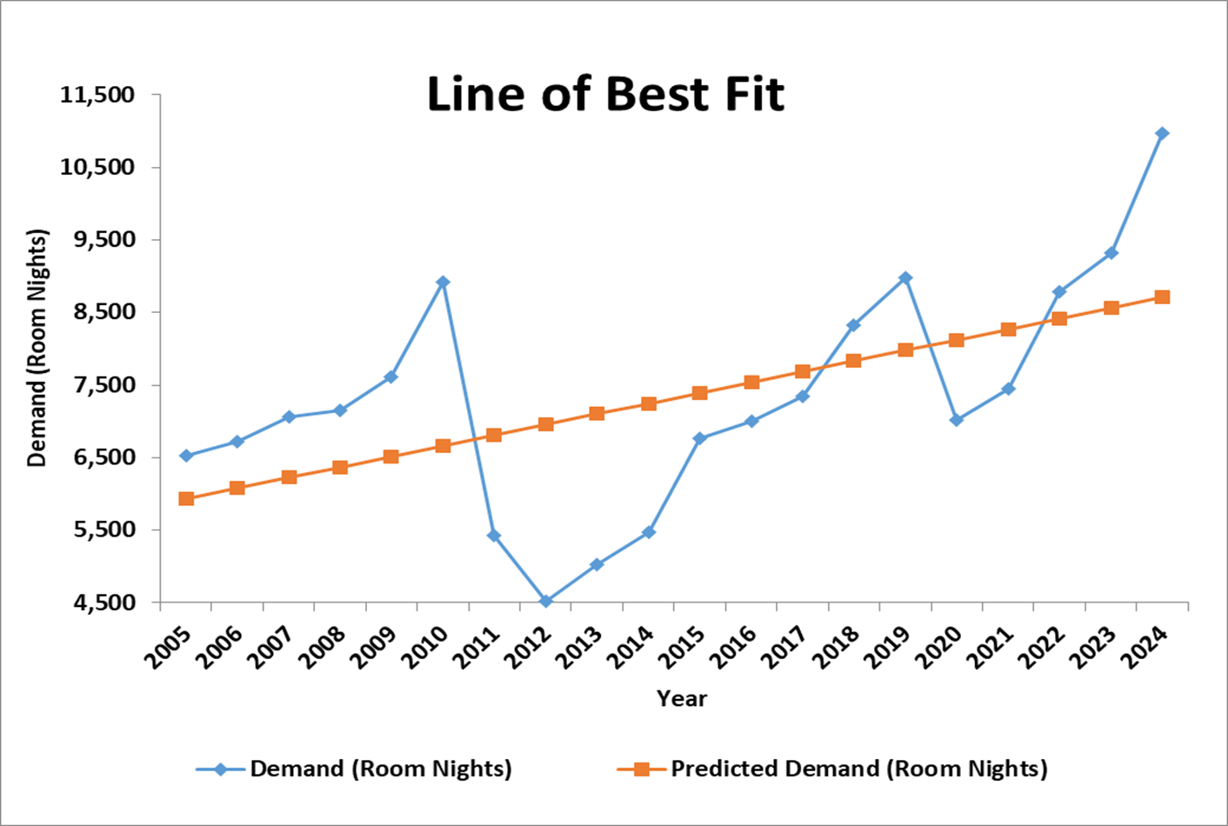

III- Comparison of Forecasting Methods:

Forecast Method | Forecasted Demand (Room Nights)
Percentage Growth | 11,342
Double Moving Average | 9,893
Simplest Weighted Average | 7,783
Time Series | 8,854

• For a good forecast:
- Use forecasting methods with extreme precautions
- Make sure historical data matches the assumptions underlying each forecasting method
- Adjust to trends, realities, expectations… → incorporate Judgmental Forecasting

