INTRODUCTION
People have always been attracted to new, unusual, or awe-inspiring attractions and events in every corner of the world. In the days before recorded history, travelers may have journeyed for miles just to experience the beauty of the setting sun across a mountain valley or to participate in a religious festival in honor of bountiful harvests. Today, we may expect more, but we are still inspired to travel by the appeal of special attractions and events. No matter whether it is the chance to attend a rock concert, to witness Shakespeare being performed in the rebuilt Globe Theater, to climb to the top of the Eiffel Tower, or to view the solitude and majesty of Ayers Rock, tourists are constantly seeking new sights, sounds, and experiences as well as the opportunity to participate in a variety of leisure activities.
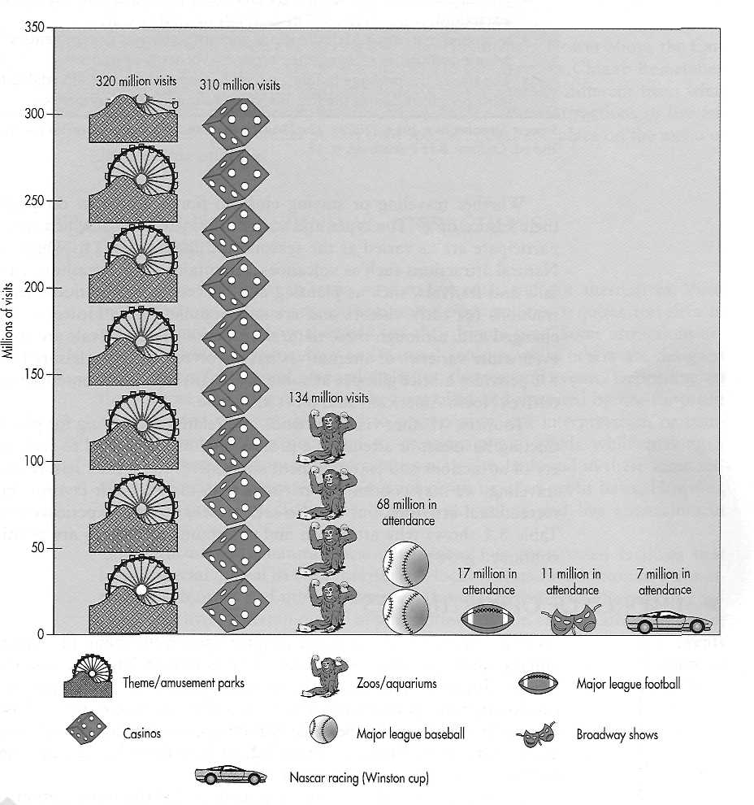
Figure 1 Entertainment activities enjoyed by North Americans.
Sources of 2003 attendance figures: International Association of Amusement Parks and Attractions. American Gaming Association. American Zoo and Aquarium Association. Major League Baseball. National Football League. League of American Theatres and Producers. NASCAR.
Table 1 Foundations for Attractions and Entertainment Growth
- Increased disposable income.
- More leisure time in terms of paid holidays, a two-day weekend for most
people, and the ability to build up extra holiday through "flextime" sys-
tems.
- Developments in technology, leading to sophisticated reservation systems
and better aircraft.
- The growth of personal mobility through mass car ownership.
- Education.
- The media, which provide images and information about destinations and
attractions.
- Increased marketing of destinations and attractions as governments and
private companies recognize the economic benefits of tourism.
- The rise of the package holiday, which helped make travel affordable for
most people and took the fear out of traveling in other countries.
Source: Swanbrooke, John. (2002). The Development and Management of Visitor Attractions, 2nd ed. Oxford: B-H Publishing, p. 18.
Whether traveling or staying close to home, just how do people spend their leisure time? The types and varieties of activities in which we choose to participate are as varied as the seasons and the locations to which we travel. Natural attractions such as volcanoes, mountains, caves, seashores, and waterfalls and festivals, such as planting and harvesting celebrations, served as attractions for early visitors and are still popular today. However, times have changed and, although these natural attractions and festivals are still popular, even wider varieties of alternatives have evolved to fill our leisure time. Figure 8.1 provides a brief glimpse at some of the attraction and entertainment alternatives North Americans find most attractive.
Tourists, whether visiting friends and relatives, traveling for pleasure, conducting business, or attending a professional meeting, tend to seek out a variety of attractions and entertainment alternatives to fill their leisure time. When traveling, we may continue to participate in many of our favorite leisure and recreational activities, but we also seek to see, do, and experience new things. Table 1 shows why attraction and entertainment venues are positioned for
continued growth.
> A WORLD OF OPPORTUNITIES
As Marie soon found out in the chapter opener, the menu of attractions and entertainment possibilities travelers face is almost limitless. Selecting which ones to discuss in this chapter is almost as difficult as deciding how to spend our leisure time as we travel. To organize this discussion, we will use the following broad categories: heritage attractions, commercial attractions, and live entertainment. As shown in Table 2, each of these broad categories can be further classified into more specific subgroups.
As you can see, this is only a sample and many more options could be added to the list. These attraction and entertainment opportunities may be selected as simply a sideline on a trip or they may be the main reason for travel. In Chapter 9, you will learn more about the important role many other
Table 2 An Attractions and Entertainment Sampler
Heritage Attractions Commercial Attractions Live Entertainment
Museums and historical sites Amusement and theme parks Sporting activities
Zoos and aquariums Gaming The performing arts
Parks and preserves Shopping Fairs, festivals, and events
Can you think of other attraction or entertainment alternatives ?
leisure-time recreational activities, such as golf, tennis, and water and snow sports, play in the overall appeal of tourism destinations.
What would you add to this list? The Philadelphia Flower Show, the Carnival of Venice, the Calgary Stampede, Golden Days in China? Remember, things that interest you and your friends may be totally different from what others might seek to experience or enjoy. Each of these attractions or live entertainment opportunities has its own special appeal and place on the menu of leisure-time offerings.
FOUNDATIONS FOR UNDERSTANDING ATTRACTIONS AND ENTERTAINMENT
Attractions are similar in some ways to live entertainment alternatives. Visiting attractions or enjoying entertainment opportunities requires travelers to make choices about how they will use their leisure time. Some attractions are planned around historic sites and natural settings while others are designed and constructed around planned activities, themes, and events. Depending on the purpose or setting, they may be controlled and operated by not-for-profit organizations that are dedicated to preservation and interpretation or commercial organizations dedicated to meeting guests' needs while making a profit. Live entertainment opportunities may also be found in these same settings and may be operated on a not-for-profit or a for-profit basis. However, there are some key differences between attractions and live entertainment venues.
Attractions are natural locations, objects, or constructed facilities that have a special appeal to both tourists and local visitors. In addition to these attractions, tourists and other visitors are also drawn to see and be part of a variety of live entertainment opportunities. While most attractions are permanent, entertainment alternatives are often temporary. In contrast, events such as fairs and festivals are temporary attractions that include a variety of activities, sights, and live entertainment venues. In addition, visitor attendance as well as the financial fortunes of almost all attractions are influenced by seasonal changes, while entertainment venues can be planned to take advantage of seasons and tourism flows. As can be seen in Figure 8.2, even at a popular location such as Disney World, there are definite highs and lows in attendance patterns.

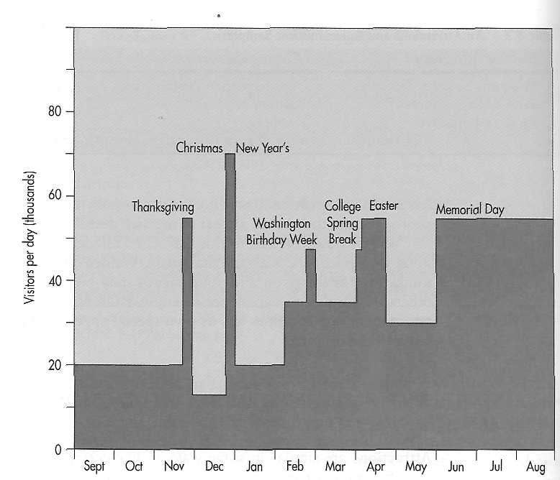

Figure .2 Annual attendance at Disney World. Attendance figures represent weekly
averages.
Source: Sehlinger, Bob. (1998). The Unofficial Guide to Walt Disney World, New York: Macmillan
Travel.
While many heritage attractions as well as amusement and theme parks are heavily used during the summer months, they may experience much less traffic in the winter months and so they close down. Even commercial attrac- tions that were originally intended to be open year-round, such as Sea "World in San Antonio, Texas, have seen their visitor numbers drop so much during the colder months that it is no longer profitable to operate on a year-round basis. Yet, these attractions may still have very appealing shoulder seasons, which can meet the needs of many visitors and still generate sufficient revenues to cover operating expenses and/or generate a profit.
This seasonality of demand raises some key operating concerns for attractions. First, from a marketing perspective, how can more visitors be attracted during less-popular shoulder seasons and how can they be encouraged to spend more time and money during their visits? Second, from a management perspective, how can large numbers of employees be recruited and trained to deliver high-quality customer service? Finally, from a financial perspective, how can cash flow be managed so that enough money is available to meet payroll and other operating expenses during the busy periods while retaining enough funds to meet maintenance and administrative expenses that occur on a year-round basis? Attraction operators address these concerns through a variety of activities.
To generate shoulder season attendance, marketing efforts have been altered to target groups of potential visitors with flexible schedules such as mature trav- elers and families with students on year-round education calendars. In addition, activities have been added to match the seasons. For example, ski resorts have added mountain biking and alpine slides to attract summer visitors, and amusement and theme parks are hosting large groups at special promotional prices during traditionally slow shoulder seasons. Attractions are also cooperating in their marketing efforts. "To help boost attendance, the Toronto Metro Zoo has entered into cross-promotions with Paramount's Canada's Wonderland, a large amusement park located about 30 minutes from the zoo."
Attracting and retaining the traditional pool of high-school- and college-aged employees through the entire busy season has been accomplished through implementing wage scales that increase as the season progresses and the payment of completion bonuses if an employee stays through a specified target date. In response to fluctuating demand, many seasonal operations are also finding it helpful to recruit older workers, especially retirees who still want to be active in the workforce or simply want to supplement their incomes. No matter what the source of employees, managers must maintain a continuous recruiting and training process to fill vacant slots created by employee turnover.
When the gates to the amusement park open or the ski lifts start running, guests expect to find a staff ready to meet their needs. They also expect the same array of foods, gifts, and other goods and amenities that they would find if they had arrived a month later when the season was in full swing. Since most attractions operate on a cash basis from admission receipts, initial pay-roll and supply expenses must be paid before revenues are received. Planning and creative thinking are required to ensure that adequate funds are available at the start of the busy season as new employees are hired and supplies are received in anticipation of arriving guests. Selling season passes at a discount at the end of the season or before the season begins and negotiating a line of credit and extended payment terms with suppliers can help to ease the cash flow squeeze. As you will soon see, these are just a few of the problems and solutions facing tourism service suppliers in this segment of the industry.
In the following sections, we will describe and explore many of the heritage attractions, commercial attractions, and live entertainment alternatives that are available for people to enjoy as they travel. You may be amazed by the variety of opportunities available in each of these categories.
HERITAGE ATTTRACTIONS
Heritage attractions can be found in a variety of shapes, sizes, and locations throughout the world. These attractions may range from a small community museum dedicated to preserving memories and experiences to incredible feats of human ingenuity and determination like the Great Wall of China. But heritage attractions are more than just museums, monuments, and archaeological treasures. They also include showplaces for natural wonders such as botanical gardens and aquariums as well as parks and preserves that are dedicated to public enjoyment and the protection of natural resources. In addition, fairs and festivals create special venues for celebrating and sharing a variety of accomplishments and cultural activities.

Archeological evidence shows that once people began to live in communities, they began collecting, preserving, and displaying various items of interest from a cultural and historical perspective. These collections have provided a means of displaying history and passing on important information to future generations as well as "outsiders." Our continuing fascination with the past has created a growing demand for museums and cultural heritage sites. Although the majority of these sites are operated on a nonprofit basis, they serve as major tourist attractions, generating important cultural and economic benefits.
Today people are attracted by the diverse cultures of other people and the past that are displayed in museums. The number, types, and locations of museums can be counted in the hundreds of thousands, and the list of people who visit these museums each year can be measured in the millions. "Those who haven't been to a museum in a while will hardly recognize the institution. In the past decade, museums have transformed themselves, constructing eye-catching new buildings at a feverish pace, replacing dusty artifact cases with high-tech interactive exhibits, and dramatically expanding restaurants and museum shops. The goal: getting more people to come, stay longer, and spend more money."
"Tourists love museums. In cities like Paris, London, Amsterdam, and New York, museums have long been major draws for out-of-town tourists. Many people will plan entire trips around a must-see exhibition; many more merely find museums a convenient place to spend a rainy afternoon. A single spectacular museum has transformed the Basque city of Bilbao from an industrial backwater into a premier tourist destination." The number of available museums throughout the world continues to grow. For example, in Europe, for every museum that existed in 1950, there are now more than four. The list of museum types is extensive but the following list provides some examples of

FYI
The Museums of Ottawa, Ontario
Canadian Museum of Civilization
Canadian Museum of Contemporary Photography
Canadian Museum of Nature
Canadian War Museum
Central Experimental Farm
Currency Museum
Fort Henry
Laurier House
Mackenzie King Estate
National Archives of Canada
National Aviation Museum
National Library of Canada
National Museum of Science and Technology
Royal Canadian Mint
Upper Canada Village

Source: Ottawa, Canada's Capital Region. Destination Planners' Guide

the more common options from which visitors can choose: general, art, history, science and technology, military, and natural history. Whether there are too few or too many museums is the subject of much debate. However, as societies grow and change, museums provide a valuable foundation for studying the past and thinking about what the future may hold.
You may have heard of or even visited Colonial Williamsburg, Virginia, or Old Quebec and recognize that they are major historical attractions. These are just two examples of historic sites, yet there are many other places beck-oning tourists and dependent on tourism revenues to continue preservation activities. Figure 8.3 shows the brochure map provided to visitors to Historic Deerfield (in western Massachusetts), one of the oldest communities in North America.
Sites like Historic Deerfield and others throughout the world are attract-ing record numbers of visitors, especially international tourists. More and more communities and countries are taking steps to preserve historical trea-sures and attract visitors through active restoration and interpretive programs. New life and uses are even being found for old industrial sites. "The owners of the Dürnberg salt mine in Hallein, Austria, which has been hosting visitors since at least 1700, decided in 1989 that salt was no longer profitable and closed down the mine. But it still earns money from 220,000 visitors each year, taking them on rides on the steep, long wooden slides that were built to transport miners." These museums and heritage sites are managed by profes-sional curators and interpretive programs are frequently conducted by docents who volunteer their time or work for very little pay.
Zoos and Aquariums
Large collections of animals, which were originally called menageries, have served as magnets for visitors since the times of the ancient Chinese, Egyp-tians, Babylonians, and Aztecs. Modern zoos (sometimes referred to as zoo-logical parks) now come in many sizes and can be found throughout the world. The Philadelphia Zoo was the first (1859) location in the United States dedicated to the large-scale collection and display of animals. While this facil-ity is still of great importance, it has been eclipsed by more spectacular zoos such as the Bronx Zoo and the San Diego Zoo. Other notable zoos around the world can be found in Montreal, Vancouver, Frankfurt, London, Paris, Moscow, New Delhi, Tokyo, and Sydney. Historically, most zoos were estab-lished as not-for-profit organizations, but that form of operation is changing as over half of all the zoos in the United States now operate as for-profit orga-nizations or only partially depend on government funding.

FYI
Vancouver Aquarium Mission Statement
"The Vancouver Aquarium, Canada's Pacific National Aquarium, is a self-sup-porting, non-profit association dedicated to effecting the conservation of aquatic life through display and interpretation, education, research and direct action."

Reprinted with permission of Vancouver Aquarium.

Some of these zoos are very large, creating a great deal of public interest and publicity as well as generating significant international tourism traffic. This interest and traffic is based on unusual exhibits, collections of animal species, and efforts to recreate the natural setting found in the wild. Even the Walt Disney Company is banking on the continued draw of zoos. In the summer of 1998, Disney unveiled its Animal Kingdom theme park, which features a blend of live displays of existing animal species and animatronic displays of species from the past, such as dinosaurs.
Although aquariums are only about half as popular as zoos and wild animal parks combined, they are increasing in number, size, and attendance. The huge Oceanarium in Lisbon, Portugal, opened as the flagship attraction of Expo '98, represents Europe's largest and possibly the most spectacular of the world's hundreds of aquariums. The first public aquarium was established in London at Regents Park in 1853. Although it eventually failed because of poor design and management, the idea of a preservation attraction devoted to water life has proven to be successful.
Many aquariums are supported and managed as not-for-profit foundations, such as Canada's largest, the Vancouver Aquarium. Others have been developed as for-profit enterprises, such as the chain of Sea World Parks. Recently, many cities, such as Camden, New Jersey, and Long Beach, California, have funded aquariums to help revitalize waterfront areas by attracting tourists and residents to oceanside regions of these cities. One of the most successful aquariums, Baltimore's National Aquarium, helped ensure the success of that city's redeveloped Inner Harbor.
Parks and Preserves
Every park and preserve is a little bit different. They may range from famous urban parks like Central Park in New York City or Hyde Park in London to forests and preserves such as Prince Albert National Park in Canada and Nairobi National Park in Kenya. Although they may be different in appearance and purpose, they are dedicated to protecting the natural beauty of landscapes, plants, and animals for future generations as well as providing visitors with open spaces for rest, relaxation, and recreation. Achieving this balance requires meeting the needs of visitors while maintaining the resources contained within the lands that have been set aside for public use. To serve all these needs, the potential impacts of all activities must be monitored and managed. For example, day-use areas and camp sites that are accessible by motorized vehicles and have full sanitary facilities require more upkeep and labor than wilderness areas that are accessible by foot or on horseback only.
The importance of parks as major tourist attractions was ushered in with the dedication of Yellowstone National Park in 1872. The U.S. National Park system has now expanded to include a variety of sites dedicated to the preservation of nature and heritage. The 379 units within the park system are grouped into 20 designations including national park, national monument, national scenic trail, and national preserve. The idea of national parks soon spread north to Canada, where in 1887, the first national park was established with the opening of Banff National Park. National parks can now be found throughout the world as countries strive to
preserve and protect their more pristine natural treasures. The grandeur and importance of some of these national parks, such as Jasper National Park in Canada and Grand Canyon National Park in the United States, have become legendary and draw millions of visitors each year to enjoy their breath-taking beauty.
Some attractions such as Nairobi and Tsavo National Parks in Kenya and Serengeti National Park in Tanzania have gained such international acclaim that they serve as some of these country's primary tourist attractions. Although people from around the world are drawn to these well-known national parks, there are also millions of acres of land that have been set aside for public enjoy-ment on the state, provincial, and local levels. From these giant parks to the small pocket parks tucked away in the corner of a city, not a day goes by that visitors and locals alike are not relaxing or taking in a little bit of nature.
The U.S. park system is a large operation in itself, with over 20,000 em-ployees and 90,000 volunteers, and spending over $2.1 billion to serve almost 290 million visitors a year. As a not-for-profit government agency, the na-tional park service depends on appropriations as well as other sources of rev-enues. These other sources include admission (user) fees as well as revenues generated from over 650 concessionaires, who supply a wide range of goods and services from food and lodging to transportation and souvenirs. However, the majority of operating funds (65% in 1994) still come from appropriations. Figure 8.4 shows how these funds are spent.
Botanical gardens are another important part of the tourism attraction mix for many communities. Some botanical gardens are renowned for their magnificent displays, and they draw visitors from all over the world. The old-est botanical garden was established at the University of Pisa in Italy in 1544. The Royal Botanical Gardens in Edinburgh, the Munich Botanical Gardens, the Montreal Botanical Gardens, and the Missouri Botanical Gardens in St. Louis are just a few examples of some of the more popular and frequently vis-ited botanic
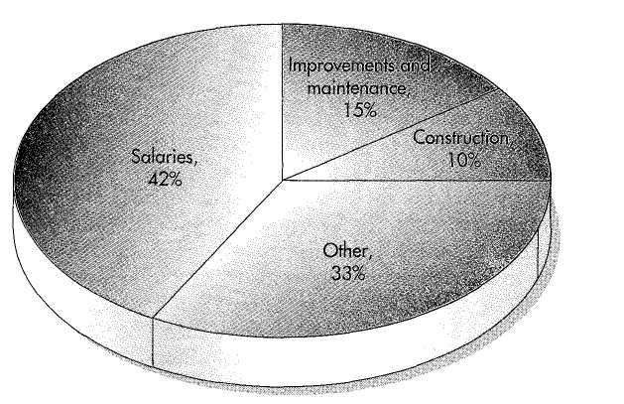
Figure 4 U.S. National Parks expenditures.
Source: Statistical Abstract of the United States 2003. Washington, DC: Government Printing Office,
p. 783.
Fairs and Festivals
Fairs and festivals hold unique positions in the attractions and entertainment segment of the tourism industry because they are a little bit of everything—her-itage attractions, commercial attractions, and live entertainment. A fair was originally a temporary marketplace set up with the idea of stimulating commerce by creating an event that would bring together buyers and sellers. You might recognize the modern-day version of the original fair as a flea market. Festivals, on the other hand, were gatherings devoted to times of celebration.
Up through the middle ages, there were fairly distinct differences between fairs and festivals. However, over time, many of the same types of activities such as food, shows, and musical entertainment could be found at both fairs and festivals. The idea of having fun at these events is probably not surprising since the word "fair" comes from the Latin word feria, which means holiday.
As commerce grew, so did the idea of fairs that were designed to be large and last for longer periods of time, maybe as long as several months. Many major exhibitions highlighting achievements and industries were held before the first "World's Fair." Two of these were the Paris Exhibition of 1889 and the 1904 Louisiana Purchase Exhibition in St. Louis, Missouri.
The idea of these very large fairs that bring together exhibitors and visitors from all over the world proved to be so popular that international leaders decided to bring some uniformity to the concept. With the signing of a diplomatic convention in Paris in 1928, 43 countries agreed to the frequency and basic operational goals of events that would be officially recognized as World's Fairs. This agreement created the International Bureau of Exhibitions (BIE), which divided the world into three zones: Europe, North and South America, and the rest of the globe. It also stipulated that fairs would not be held in consecutive years in any one country and that no fees would be charged for the exhibits of foreign governments. Since its formation, there have been a number of notable World's Fairs including the New York World's Fairs (1934 and 1964); Brussels Universal and International Exhibition (1958); Expo '67 in Montreal, Canada (1967); Expo '70 in Osaka, Japan (1970); Expo '86 in Vancouver, Canada (1986); World Expo '88 in Brisbane, Australia (1988); Expo '92 in Seville, Spain; and Expo 2000 in Hanover, Germany. The most recent BIE-sanctioned exhibition was in Aichi, Japan (2005). One future BIE-sanctioned exhibition will be in Shanghai, China (2010).
Another very popular visitor attraction is the regional, state, or county fair. Most of these have evolved around the display of agricultural and livestock exhibits, but they often include industrial exhibits and many other entertainment activities. The Eastern States Exhibition, or "The Big E" as it is called, is an annual, regional 10-day fair held each summer in West Spring-field, Massachusetts; it celebrates the crafts, industries, and agricultural prod-ucts of the northeastern states of the United States. Some of these fairs, such as the Canadian National Exhibition in Toronto and the National Western Livestock Show in Denver, draw tens of millions of visitors. However, whether it is a World's Fair, state fair, or county fair, people still travel from all over to ex-hibit and participate in the festivities.
Festivals celebrate a variety of special occasions and holidays. Some are derived from religious observances, such as New Orleans' or Rio de Janeiro's huge Mardi Gras festivals. Other festivals focus on activities as peaceful as ballooning (the Albuquerque Balloon Festival) or as terrifying as the running of the bulls in Pamplona, Spain. Often, festivals center on the cultural heritage of an area, such as the clan festivals that are prominent in the North Atlantic province of Nova Scotia. Seasons are also reasons for festivals such as the Winter Carnival held in Quebec City or Milwaukee's Summerfest. More re-cently, food has become the center of attention at locations such as the Na-tional Cherry Festival in Traverse City, Michigan, or the Garlic Festival in Gilroy, California.
Anytime people visit a fair or a festival, it is a time of celebration, and what celebration would be complete without fun and food? From the Okto-berfest in Munich to the Three Rivers Festival in Fort Wayne, Indiana, festival-goers can expect to find a tempting array of music, foods, and drinks. Community leaders have discovered that tourists can be drawn to even the smallest communities for fun-filled events. The National Cluck-off held during Chicken Days in Wayne, Nebraska, or the Oatmeal Cook-off held at the Oat-meal Days in Oatmeal, Texas, attest to people's desires to attend and be a part of festivals from the sophisticated to the seemingly silly.
In addition to these many heritage attractions, culture provides innumer-able other methods to attract visitors.
COMMERCIAL ATTRACTIONS
In addition to the heritage attractions just discussed, a host of commercial attractions has been developed to meet travelers' leisure-time needs. Whether it's the thrill of the roller coaster plunge, the excitement of gaming, or the joy of an armload of boxes after a day at the mall, both tourists and locals welcome the opportunity to visit and enjoy these attractions.
Amusement Parks
The first amusement parks, which were called pleasure gardens, were built in England and France. Some of the largest and most popular amusement parks such as Gardaland on Italy's Lake Garda and Tivoli in Denmark attract mil- lions of visitors each year. As the name "pleasure garden" implies, these at-tractions began as manicured gardens designed to provide a temporary escape for city dwellers from the everyday drudgeries of life. Rides such as carousels, games, and food and drink stands were added to these pleasure gardens to meet guest needs.
The idea of parks with rides and other entertainment activities soon found its way to the United States. Interest in amusements in the United States heightened when the ferris wheel was introduced at the 1893 Chicago World's Fair. The name for this new amusement that became the centerpiece of most early amusement parks was taken from its inventor, George Washington Gales Ferris.
Lights, sounds, rides, games of chance, food, and a flurry of activities proved to be natural draws for those early thrill-seeking visitors to such places as Coney Island in Brooklyn or the Steel Pier in Atlantic City. Many smaller amusement parks in the United States were originally located at the edge of town, where the trolley lines stopped. These amusement parks, called "trolley parks," were established as marketing tools to encourage ridership during the slow weekend periods. As automobiles and buses replaced trolleys, these and other amusement parks faded in popularity as their captive audiences disap-peared. However, the concept of family fun and amusement was kept alive during the first half of the 20th century by traveling carnivals that moved across the country as a source of entertainment at many fairs and festivals until a landmark event that occurred in 1955. That year marked the opening of Disneyland in Anaheim, California.
Disneyland was much more than an amusement park. Although it drew on some of the basic attributes of an amusement park, Disneyland was the first theme park, and its opening served to rekindle respectability and interest in amusement parks.⁷ Since that time, the operations of amusement parks have become more sophisticated, with technology playing a far more important role. However, the basics of fun, excitement, and fantasy remain the keys to amusement park successes.

FYI
Roller Coasters
Cedar Point Amusement Park in Sandusky, Ohio, has done it again! In 2003, the wildest roller coaster of them all opened, named the Top Thrill Dragster. What a thrill it is! As the first "strato-coaster," breaking the 400-foot barrier, it rises 420 feet into the air. Designers claim a 120-mph top speed and a 90-degree ascent and descent—that's straight up and straight down, putting 6 Gs on the riders for one second!!!
Track length: 2,800 feet
Lift height: 420 feet
Angle of lift: 90 degrees
Angle of descent: 90 degrees
Speed: 120 mph
Ride capacity: Approximately 1,500 per hour

Source: http://www.cedarpoint.com/public/omsode_park/rides/thrill/ttd.

Amusement parks, family entertainment centers, and water parks serve as important recreational outlets for their host communities and also attract con-siderable tourism interest from the region. Some of the larger amusement parks that may be recognizable to you include Six Flags/Elitch's Garden in Denver; Kentucky Kingdom in Louisville; Kennywood Park (one of the origi-nal trolley parks) in West Miffin, Pennsylvania; Grand Slam Canyon in Las Vegas; and Cedar Point in Sandusky, Ohio (the largest in North America).
Theme Parks
The distinction between amusement and theme parks is beginning to blur, but there are several unique characteristics that set them apart. Theme parks cre-ate a destination in themselves. By combining entertainment, food, and bever-ages and an environment different from that found outside the gates, visitors are allowed to escape reality as they enter. Through the magic of technology and elaborate staging, theme parks can replicate almost any location in the world. As visitors are transported into this simulated environment, they are af-forded the luxury of being in another location without the expense or any of the potential problems of faraway travel.
In addition to providing a theme around which a park operates, such as the Dark Continent (Africa) at Busch Gardens in Tampa, Florida, or Ocean Park in Hong Kong, successful parks also meet several other basic require-ments. These requirements include:
- A sufficient target market of day-trippers who have the necessary dis-
posable income to visit and enjoy park attractions.
- A site of at least 100 acres or more of rolling or well-drained land for
the park, parking, buffer areas, room for future expansion, and easy
highway access.
- Access to a large pool of prospective part-time employees.
- A minimum of 140 rain-free days between April 1 and November 1.
- Access to large quantities of water since most theme parks usually con-
tain popular water attractions.⁷
There may be a tendency on the part of North Americans to think that they are the center of amusement park attractions. However, remember that the idea was imported from Europe and a trip to that continent will show that it has not lost its place in the theme park spotlight. Blackpool Pleasure Park in Blackpool, England; Parc Asterix and Disneyland Paris just outside Paris ("the single biggest tourist attraction in Europe"); Port Aventura on Spain's Costa Dorado; Efteling Leisure Park in Kaatsheuvel, Netherlands; LEGOLAND in Billund, Denmark; and Phantasialand between Cologne and Bonn, Germany, are just a few of Europe's premier parks.⁸ Other park loca-tions around the world, such as Tokyo Disneyland in Japan; Dreamworld at Coomera on Australia's Gold Coast; Lotte World in Seoul, Korea; La Ronde in Montreal, Quebec; and Burlington Amusement Park on Prince Edward Is-land, Canada, serve to highlight the international appeal of these attractions.
"The contemporary American typically associates theme parks with con-cepts of permanence, gardened park-like settings and single price admission"

Table 4 Amusement/Theme Park Revenue Sources
Revenue Sources in U.S. Dollars Mean Percentage of Total Revenue
Admissions 50%
Food 19%
Merchandise 11 %
Games 7%
Parking 3%
Other 10%
Total 100%
Source: International Association of Amusement Parks and Attractions. (2000). Amusement In-dustry Abstract.
(p. 51 ). Theme parks meeting these criteria range from elaborate parks such as Disney World in Florida and Canada's Wonderland in Toronto to local and specialty theme parks such as Worlds of Fun in Kansas City, Missouri, and Six Flags over Georgia, in Atlanta, providing a wide range of choices for the con-sumer. To differentiate product offerings and successfully compete, theme park operators must become more aware of consumer perceptions and concerns. There are several core conditions that must be met by theme park operators to retain repeat patronage and attract new patrons.
From an operating point of view, parks must create a family atmosphere and be clean and visually pleasing. Park designers must provide a wide variety of rides, especially roller coasters and water rides, while reducing the percep-tion of crowding. In addition to activities with an educational focus, new rides and features must be added on a periodic basis to maintain guest interest and ensure repeat patronage. To fund these changes, parks rely on six major sources of revenue (see Table 8.4). As operators of theme parks such as Cy-press Gardens in Florida have learned, you must appeal to a broad demo-graphic range to attract sufficient numbers of visitors to achieve profitability.¹⁰

GAMING

Casino gaming has experienced an explosive growth in popularity and avail-ability across the United States and Canada during the past few years. When gaming was legalized in Nevada in 1931 to attract tourists during the Depres-sion, few would have envisioned that some type of gaming operation would one day be found within easy driving distance of almost everyone in the United States and Canada.
The increasing availability and ease of access to gaming locations has re-sulted in more Americans visiting casinos than attending major league and col-legiate football games, arena concerts, symphony concerts, and Broadway shows combined.¹¹ "From New Mexico to Connecticut, casinos all over the country are in the midst of a high-stakes gamble: remaking themselves into full-service, if not luxury, vacation destinations. Taking their cue from Vegas, they're throwing up plush hotels, high-end shopping malls and even kiddie amusement parks, all in an unprecedented bid for the family-vacation dollar."
Five basic factors combine to explain the current success and future prospects of the gaming industry. First, voters have been increasingly willing to approve new gaming alternatives because these activities have come to be viewed as a "voluntary tax" or form of economic development while politicians have been unwilling or unable to pursue new taxes. Second, more people than ever before are choosing casino gaming as an acceptable leisure activity. Four out of five adults now report that they consider casino gaming to be a "fun night out." Third, retirees comprise the single largest segment of the casino market, and their numbers continue to grow. Fourth, casinos have devised marketing programs to attract the previously ignored "low roller," and fifth, expanded availability of gaming opportunities is attracting many individuals who have never before visited casinos for entertainment.
Prior to the 1990s, traditional casino gaming was not adopted by a majority of Americans because they needed to travel to Atlantic City or Nevada to participate in legal gaming. This made gaming relatively unattractive as a leisure-time activity as compared with closer tourism attractions and activities. Now, with more locations and new technologies, the characteristics of gaming as a leisure-time activity have changed. Currently, there are four broad categories of gaming alternatives:
- Traditional, full-scale casino gaming, including the well-established lo
cations in Nevada and Atlantic City.
- Historic, limited-stakes operations such as those in Colorado's mining
towns.
- "Dockside" (riverboat) casinos, such as those operating on the Missis
sippi and Gulf Coast.
- Gaming on Native American reservations that varies all the way from
limited-stakes, small-scale operations such as the Sky Ute Casino in
Ignacio, Colorado, to large-scale Vegas-style operations such as Fox-
woods on the Mashantucket Pequot reservation in Connecticut.
Table 5 highlights some of the milestones in the growth and availability of gaming activities throughout North America.
Casino gaming is one of the most regulated businesses in the United States. Gaming businesses must comply with local, state, and federal regulations. These include complying with tax laws, treasury department regulations, and rules governing alcohol consumption, types of games allowed, and sizes of bets. The size of casino operations is measured by gross gambling revenues (GGR). GGR is the amount wagered minus the winnings returned to players. The 2002 GGR was $68.8 billion.

Emerging Gaming Segments

The development of new games and expanded gaming availability has given rise to several gaming segments, each with a profile somewhat different from the others and each with different benefits sought from gaming. Four broad segments appear to be emerging:
1. High rollers. This segment is composed of sophisticated gamblers (both domestic and foreign), to whom traditional gaming was origi-
Table 5 Milestones in Gaming's History and Growth
Year Event
1931 Gambling legalized in Nevada
1969 Casino gambling legalized in Canada
1978 Gambling legalized in Atlantic City
1988 Indian Gaming Regulatory Act making gaming possible on tribal lands in almost every
state
1989 Limited-stakes gaming in Deadwood, South Dakota; Central City, Cripple Creek, and
Black Hawk, Colorado
Limited-stakes riverboat gaming legalized in Iowa (limits removed in 1994) Government-operated Crystal Casino opens in Winnepeg, Canada
- Riverboat gaming legalized in Illinois
- Riverboat and dockside gaming legalized in Mississippi
- Cruise ships permitted to operate gaming activities on the high seas
- Gaming legalized in New Orleans
Riverboat gaming legalized in Louisiana
2004 Legalized gaming being seriously considered in Mexico where all gambling has been
outlawed since 1935
nally targeted. These gamers tend to be wealthy, older, and male. High rollers tend to play games of skill rather than luck.
- Day-trippers. Retirees dominate this segment. These gamers make
several short-duration trips to operations within easy driving distance
and wager relatively significant amounts per trip, but tend to play
slots and other video gaming options.
- Low-stakes/new adopters. Gamers in this segment have discovered
and accepted gaming as an interesting day or evening diversion when
it is close to home or when traveling. Members of this segment in-
clude the growing cadre of aging baby boomers and their retiree par-
ents, with the time and money to enjoy the entertainment associated
with gaming. Other gamers in this segment are younger women who
tend to play video gaming alternatives and Generation X young
adults.
- Family vacationers. Due in part to the development of complementary
tourism attractions such as theme parks, this segment tends to gamble
as an off-shoot of a family vacation.
Through the use of customer loyalty programs, casinos are collecting market-ing data to target each segment and cross-sell related products and services.

Place Your Bets

The availability of new and expanded gaming opportunities for tourists to try their hands at "Lady Luck" are likely to continue to grow. Although many present and future gaming locations do not have the marketing advantages of destinations such as Macao, Monaco, or Las Vegas, they do have one factor in common with already well-established and successful operations in places like Hull, Ontario; Atlantic City; and Laughlin, Nevada: a location within easy driving distance of a large population base. This ease of access, combined with
the social acceptance and novelty of gaming as recreation, has attracted many first-time gamers and should continue to generate repeat visits.
Serving this growing market for locals and tourists who are seeking the excitement and entertainment of gaming is creating attractive investment and employment opportunities. In contrast to other segments of the tourism indus-try that operate on very thin profit margins, gaming generates margins of up to 35%. Gaming opportunities continue to grow as visitors can choose from a variety of venues including riverboats, Indian reservations, destination resort casinos, and the traditional casino meccas of Las Vegas and Atlantic City. In-ternational destinations such as Macao, Isla De Margarita off the Venezuelan coast, and Bermuda tempt tourists to gaming tables from around the world. Table 8.6 shows that as many new venues have opened, gaming revenues are no longer restricted to traditional gaming locations.
Most of this growth can be attributed to the attractiveness of slot ma-chines, which generate over 70% of casino revenues. The average quarter slot gamer feeds $2,500 into machines within a three- to four-hour playing session. Nevada state law requires that casinos yield a minimum 75% payout, but most of the casinos entice players with much higher payouts. New casinos will frequently offer the highest payouts, often returning 93.4% to players while
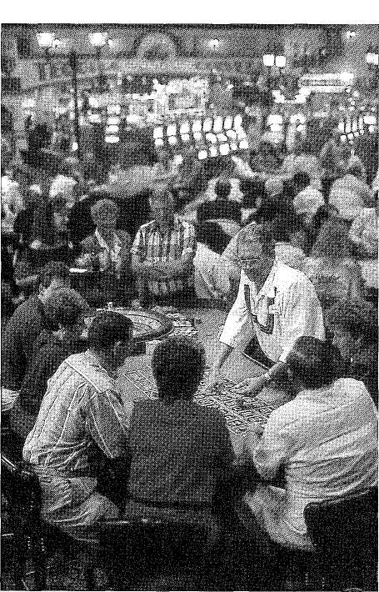
Playing the odds.
Photo courtesy of Harrah's Casinos.

tion mix is at the Mall of America, management is not counting on its past decisions for future success. They know customers can become jaded, so they are planning new attractions to keep visitors returning. The recent addition of Underwater World, a 1.2-million gallon walk-through aquarium, will provide one more reason for shoppers to plan a trip to experience a unique mall envi-ronment.
Other malls such as Woodfield Mall in Schaumburg, Illinois, and Gurnee Mills Mall in Gurnee, Illinois, do not rely on added attractions to draw in visitors, just good, solid shopping opportunities. And does this work? The answer is a definite yes, as these two malls are Illinois' number one and two tourist attractions, drawing in over 28 million visitors a year. Marketing efforts that provide incentives to tour operators and support from tourist bureaus keep the shoppers coming back in record numbers.
When you think of a trip to the Big Apple you probably imagine visiting its famous sites, such as the Empire State Building and the Statue of Liberty. But international visitors think of New York City as a shoppers' paradise. Shopping is the number one activity for overseas visitors to New York City, who account for over 70% of visitor retail sales.²⁶ In fact, Bloomingdale's claims that it is the city's third largest tourist attraction.²⁷
Tourism in Action

A mall is a mall is a mall. Not so! Imagine a shopping and entertainment paradise that covers over 110 acres and attracts over 20 million visitors a year. Now, imagine this attraction sitting on the plains of Canada in the city of Edmonton, Alberta. If you have not visited this "shopping center," then you have missed seeing and experiencing the biggest mall on Earth—West Ed-monton Mall. This mammoth package of tourist services attracts people from all over the world in record numbers.
The West Edmonton Mall is not like most other malls: It is massive in size and excites the imagination. Sure, it has shops, shops, and more shops. In fact, it has more than 800 stores. But the mall has more than shops and shopping to attract visitors. Almost 40% of the mall's space is dedicated to attractions as well as a hotel and more than 100 food outlets, and it is all under one roof. It takes over 15,000 employees to accomplish all of the administrative and operating duties to keep this giant enterprise ticking.
The Fantasyland Hotel has 355 guest rooms, but 127 of these rooms have been specially

"themed" and decorated to fulfill guests' desires for travel adventures. When it's time to take a break from shopping there are a number of things to do and see, including Galaxyland Amusement Park, World Waterpark, Ice Palace, Europa (miniature) golf course, Deep Sea Submarine Ad-venture, Dolphin Lagoon and Sea Life Caverns, a full-scale casino, a bowling emporium, three cin-ema complexes, and a replica of one of the ships of Christopher Columbus.
Deciding what to do can be as difficult as de-ciding what to buy. Viewing the many animal at-tractions exhibiting more than 200 species of animals such as dolphins, fish, exotic birds, and a colony of breeding penguins takes you back to nature. A ride on the Mindbender roller coaster will find you dropping 14 floors at over 70 mph, while the tranquility of the submarine ride will transport you to exotic coral reefs. Or, you could splash down into the water park that covers an area the size of five NFL football fields.

Source: <http://westedmall.com>; and Carlisle, Tamsin. (1997, March 7). Gamble by the world's biggest mall pays off. Wall Street Journal, pp. Bl, B18.

When it comes to shopping, the motto "build it and they will come" works! Ontario Mills Mall, located 60 miles east of Los Angeles, California attracts over 20 million shoppers each year. About 40% of these shoppers are tourists, coming from as far away as Australia, Hong Kong, Japan, Malaysia, and the Philippines, while tour busses, approximately 2,000 a year, bring in the not-so-distant tourists. All of this tourist traffic doesn't just happen by accident. The mall has an office of tourism and marketing staff targeting not only countries, but also tour operators, airlines, and other travel industry rep-
resentatives.
Visiting heritage and commercial attractions and participating in activities at these locations could easily be classified as entertainment. However, live enter-tainment opportunities fill a special need for travelers and others seeking addi-tional leisure-time activities. The choices of live entertainment venues can run from the deafening crowds at hallmark sporting events such as the World Cup or the Super Bowl to the serene pleasures of the ballet.
Sportin0 Activities
As highlighted in Chapter 2, sports have drawn visitors to scheduled events from near and far for thousands of years. Over 3,500 years ago, the Greeks initiated the idea of staging athletic competitions. The most famous of these competitions were the Olympic Games held in Olympia. The competitions began as part of their religious festivals and were staged in towns throughout Greece and Italy. The original competitions in Greece were organized as con-tests, but the Romans expanded the idea and staged them as games for public entertainment. Although the grand athletic competitions and festivals such as the classical Olympic Games faded and disappeared under Roman rule, the idea did not go away. With the formation of the International Olympic Com-mittee (IOC), the modern-day Olympic Games were reborn and a new athletic tradition began in Athens, Greece, in 1896. This first modern Olympic compe-tition was held in the summer and drew less than 500 athletes from 13 na-tions.²⁹ In contrast, the 2000 Summer Olympics held in Sydney, Australia, drew over 10,651 athletes from 199 nations and territories. The Winter Olympic games were not added until 1924, with the competition first staged in Chamonix, France.
Modern-day professional and intercollegiate sporting events such as foot-ball, soccer, baseball, basketball, and hockey draw millions of visitors each year to regularly scheduled games and playoffs. Special sporting events such as the Super Bowl, the Stanley Cup Championship, the World Cup, the Pro Rodeo Championship, the Indianapolis 500, and the College World Series, to name just a few, attract international attention and vast numbers of spectators to host communities each year. These same sports are often played at local and regional levels and, although they may not draw the same crowds, they are just as important to the participants and spectators who are attracted to the excitement of the event. In addition to team sports, a wide array of sporting activities such as golf, tennis, swimming, hiking, biking, fishing, rock climb-ing, and snowboarding/skiing round out the list of alternatives from which travelers can choose.
According to Mike Helton, senior vice president and chief operating officer of the National Association for Stock Car Racing, better known as NASCAR, stock car racing is the fastest growing spectator sport in the United States. At-tendance has continued to increase in all categories, making NASCAR the most popular sporting event based on attendance at each event.
The Performing Arts
The performing arts have been a popular form of entertainment for thousands of years. For some areas, such as Branson, Missouri, they serve as primary tourism revenue generators; for other areas, such as Las Vegas, they serve as one more ingredient in the menu of attractions and entertainment that the area can boast of to interest visitors to encourage them to extend their stay. Live entertainment has always been a draw for travelers. For some it may be the opportunity to select from a wide variety of plays in London's theater dis-trict; for others, a chance to attend a concert featuring the newest entertain-ment idol. For still others, it could be the opportunity to attend a country jam or an opera performance.
The classical performing arts include theater (live stage plays, not the movies), ballet, opera, concerts, and the symphony. Contemporary performing arts include stand-up and improvisational comedy, rock concerts, and even the band that is playing in your favorite local "hotspot." Performing arts enter-tainment, especially the classical forms, are frequently offered in locations such as concert halls (the Lincoln Center in New York City and the Kennedy Center in Washington, DC) developed for the express purpose of showcasing the art form.
Theaters, concert halls, and other large-seating-capacity facilities exist in almost all cities throughout the world and each, no matter how plain or im-pressive, serves as a draw for visitors. Some, such as the Sydney Opera House, are even renowned as landmarks. Many performing arts companies, whether a repertory acting group or symphony orchestra, have a season (a few months each year) when they stage productions and perform for the public. For exam-ple, the Desert Chorale is a classical choir that performs each summer in Santa Fe, adding to the entertainment options offered in that renowned arts city.
Think for a moment of all the performing arts productions you enjoyed in the past year. Which were of the classical form and which would be considered contemporary? Maybe you even have experience as a participant in the per-forming arts? Band? Chorus? Local theater?

